# NFJS Hello World Step Function

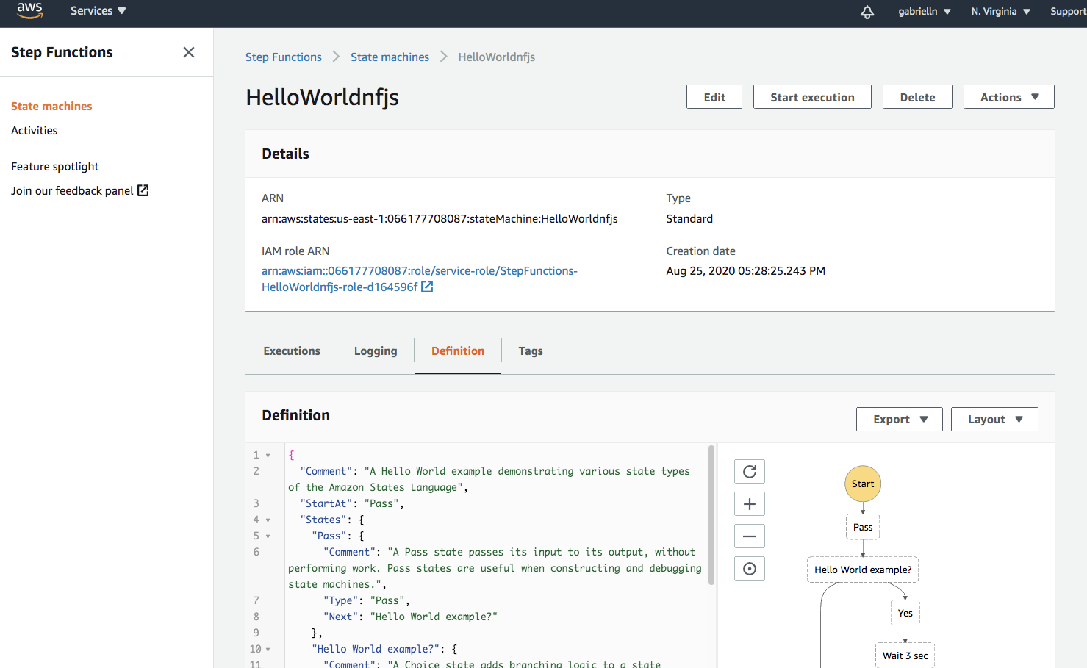

## Try with IsHelloWorldExample as true or false

{

"IsHelloWorldExample": true

}

